**ASSIGMENT-4**

**1. Create a stored procedure in the Northwind database that will calculate the average value of Freight for a specified customer.Then, a business rule will be added that willbe triggered before every Update and Insert command in the Orders controller,and will use the stored procedure to verify that the Freight does not exceed the average freight. If it does, a message will be displayed and the command will be cancelled.**

CREATE PROCEDURE dbo.sp_AverageFreight (@CustomerID nchar(5))

AS

BEGIN

SET NOCOUNT ON;

DECLARE @AverageFreight decimal(10, 2);

SELECT @AverageFreight = AVG(Freight)

FROM Orders

WHERE CustomerID = @CustomerID;

SELECT @AverageFreight AS AverageFreight;

END;

CREATE TRIGGER tr_Orders_FreightCheck

ON Orders

FOR INSERT, UPDATE

AS

BEGIN

SET NOCOUNT ON;

DECLARE @AverageFreight decimal(10, 2);

DECLARE @Freight decimal(10, 2);

DECLARE @CustomerID nchar(5);

SELECT @CustomerID = i.CustomerID, @Freight = i.Freight

FROM inserted i;

EXEC sp_AverageFreight @CustomerID, @AverageFreight OUTPUT;

IF (@Freight > @AverageFreight)

BEGIN

RAISERROR ('The Freight value exceeds the average Freight for the specified customer.', 16, 1);

ROLLBACK TRANSACTION;

END;

END;

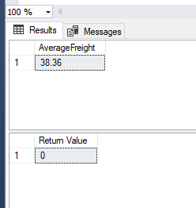

**2. write a SQL query to Create Stored procedure in the Northwind database to retrieve Employee Sales by Country**

CREATE PROCEDURE EMPLOYEESALESBYCOUNTRY @EMPLOYEEID INT

AS

BEGIN

SELECT O.ShipCountry,SUM(OD.UnitPrice*OD.Quantity)

FROM Employees E

INNER JOIN Orders O ON

E.EmployeeID=O.EmployeeID

INNER JOIN [Order Details] OD ON OD.OrderID =O.OrderID

GROUP BY O.ShipCountry

END;

EXEC EMPLOYEESALESBYCOUNTRY 2

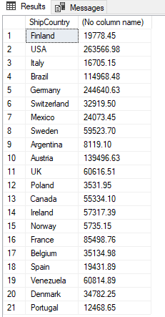

**3. write a SQL query to Create Stored procedure in the Northwind database to retrieve**

**Sales by Year**

CREATE PROCEDURE dbo.GetSalesByYear (@Startdate DATETIME,@Enddate DATETIME)

AS

BEGIN

SELECT Orders.ShippedDate, Orders.OrderID, "Order Subtotals".Subtotal, DATENAME(yy,ShippedDate) AS Year

FROM Orders INNER JOIN "Order Subtotals" ON Orders.OrderID = "Order Subtotals".OrderID

WHERE Orders.ShippedDate Between @Startdate And @Enddate

END;

EXEC GetSalesByYear @Startdate ='1996-01-01 00:00:00.000',@Enddate='1998-07-04 00:00:00.000';

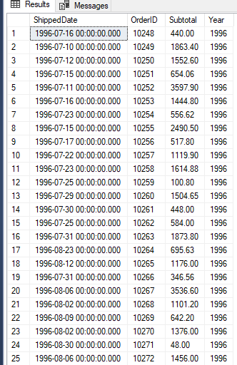

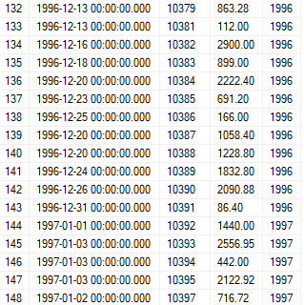

**4. write a SQL query to Create Stored procedure in the Northwind database to retrieve**

**Sales By Category**

CREATE PROCEDURE dbo.GetSalesByCategory (@CategoryName nvarchar(15), @OrdYear nvarchar(4))

AS

IF @OrdYear != '1996' AND @OrdYear != '1997' AND @OrdYear != '1998'

BEGIN

SELECT @OrdYear = '1998'

END

BEGIN

SELECT @CategoryName,TotalPurchase=ROUND(SUM(CONVERT(decimal(14,2), OD.Quantity * (1-OD.Discount) * OD.UnitPrice)), 0)

FROM [Order Details] OD, Orders O, Products P, Categories C

WHERE OD.OrderID = O.OrderID

AND OD.ProductID = P.ProductID

AND P.CategoryID = C.CategoryID

AND C.CategoryName = @CategoryName

AND SUBSTRING(CONVERT(nvarchar(22), O.OrderDate, 111), 1, 4) = @OrdYear

GROUP BY ProductName

END;

EXEC SALEBYCATEGORY @CategoryName='Produce',@OrdYear=1996

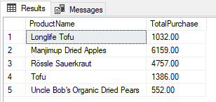

**5. write a SQL query to Create Stored procedure in the Northwind database to retrieve**

**Ten Most Expensive Products**

CREATE PROCEDURE TopTenMostExpensiveProducts

AS

BEGIN

SET ROWCOUNT 10

SELECT Products.ProductName AS TenMostExpensiveProducts, Products.UnitPrice

FROM Products

ORDER BY Products.UnitPrice DESC

END;

EXEC TopTenMostExpensiveProducts

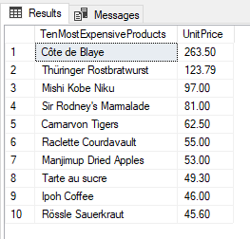

**6. write a SQL query to Create Stored procedure in the Northwind database to insert**

**Customer Order Details**

CREATE PROC smInsertOrderDetails

@OrderID INT,

@ProductID INT,

@UnitPrice MONEY,

@Quantity SMALLINT,

@Discount REAL

AS

BEGIN

INSERT INTO [Order Details]

(OrderID, ProductID, UnitPrice, Quantity, Discount) VALUES

(@OrderID, @ProductID, @UnitPrice, @Quantity,@Discount)

END

**7. write a SQL query to Create Stored procedure in the Northwind database to update**

**Customer Order Details**

CREATE PROC smUpdateOrderDetails

@OrderID INT,

@ProductID INT,

@UnitPrice MONEY,

@Quantity SMALLINT,

@Discount REAL

AS

BEGIN

UPDATE [Order Details]

SET UnitPrice = @UnitPrice, Quantity = @Quantity, Discount = @Discount

WHERE OrderID = @OrderID AND ProductID = @ProductID

END